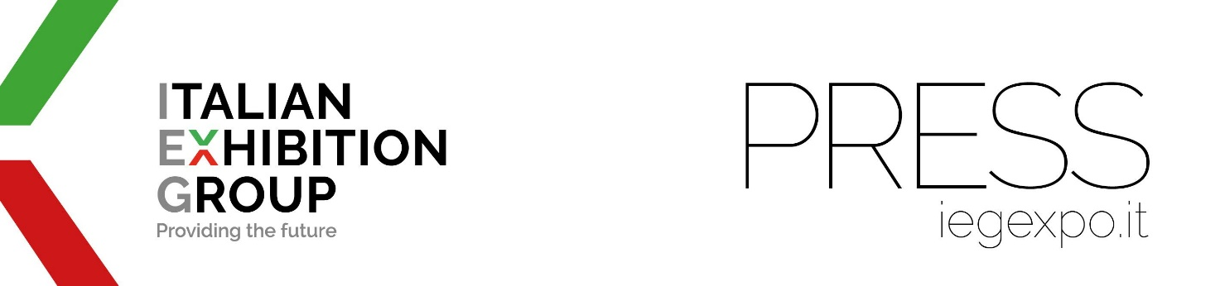

press release
(English translation)

São Paulo: IEG acquires InfraFM Expo
and enters the facility management market

- The sector generates €70 billion in the domestic market alone
- Italian Exhibition Group continues its expansion process in Brazil

Brazil, São Paulo, 3rd June 2024 - Italian Exhibition Group (IEG), a leading organiser of global trade shows and conferences, has acquired 100% and taken over the organisation of InfraFM Expo, the trade show scheduled from tomorrow to 5th June in Brazil, at Expo Centre Norte in São Paulo.
Expo InfraFM encompasses facility, property and workplace management in a market with more than 200,000 condominiums. But Brazil is also a country where business and shopping centres are becoming increasingly supersized, integrating the most diverse services to bring families closer to the workplace.
InfraFM Expo is therefore an event that provides solutions, trends and technologies for the management of condominiums, facilities, properties and workplaces through the philosophy of general contractors.

“Thanks to this acquisition,” says IEG CEO, Corrado Peraboni, “we are entering a market worth €70 billion in Brazil which is expected to exceed €2 trillion worldwide by 2025. We have ambitious plans and aim to be one of the top five exhibition organisers in the country.”
“In 2023,” Graziano Messana, managing director of IEG in Brazil, emphasises, “we acquired 100% of MundoGeo, bringing together four sectors: drones, space, geolocation and eVtol (“flying machines”). The event grew by 50% in the first edition under our management. We foresee similar high development potential for INFRA FM, also thanks to constant collaboration with its founder.”
“‘In addition to the aforementioned trade shows,” adds Francesco Santa, IEG's international business development director, “our Group, which started operating in Brazil in 2022, also organises Fesqua, Ebrats and BTFF with a product portfolio that covers a varied and strategic range of sectors from wellness to civil construction.”

In 2023, Italian Exhibition Group recorded revenues of €212.4 million (+32% compared to the previous year), with an EBITDA of €49.5 million.

ITALIAN EXHIBITION GROUP PRESS CONTACTS
head of corporate communication & media relations: Elisabetta Vitali |
press office manager: Marco Forcellini, Pier Francesco Bellini | international press office coordinator: Silvia Giorgi media@iegexpo.it

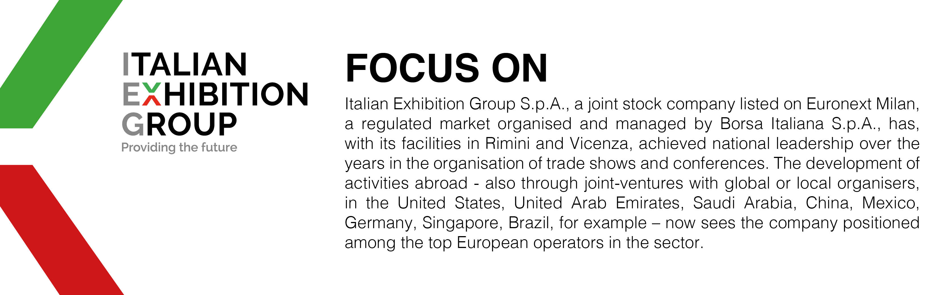

This press release contains forecast elements and estimates that reflect the management´s current opinions (´forward-looking statements´), particularly regarding future management performance, realization of investments, cash flow trends and the evolution of the financial structure. For their very nature, forward-looking statements have a component of risk and uncertainty, as they depend on the occurrence of future events. The effective results may differ (even significantly) from those announced, due to numerous factors, including, only by way of example: food service market and tourist flow trends in Italy, gold and jewellery market trends, green economy market trends; the evolution of raw material prices; general macroeconomic conditions; geopolitical factors and evolutions in the legislative framework. Moreover, the information contained in this release, does not claim to be complete, and has not been verified by independent third parties. Forecasts, estimates and objectives contained herein are based on the information available to the Company as at the date of this release.

